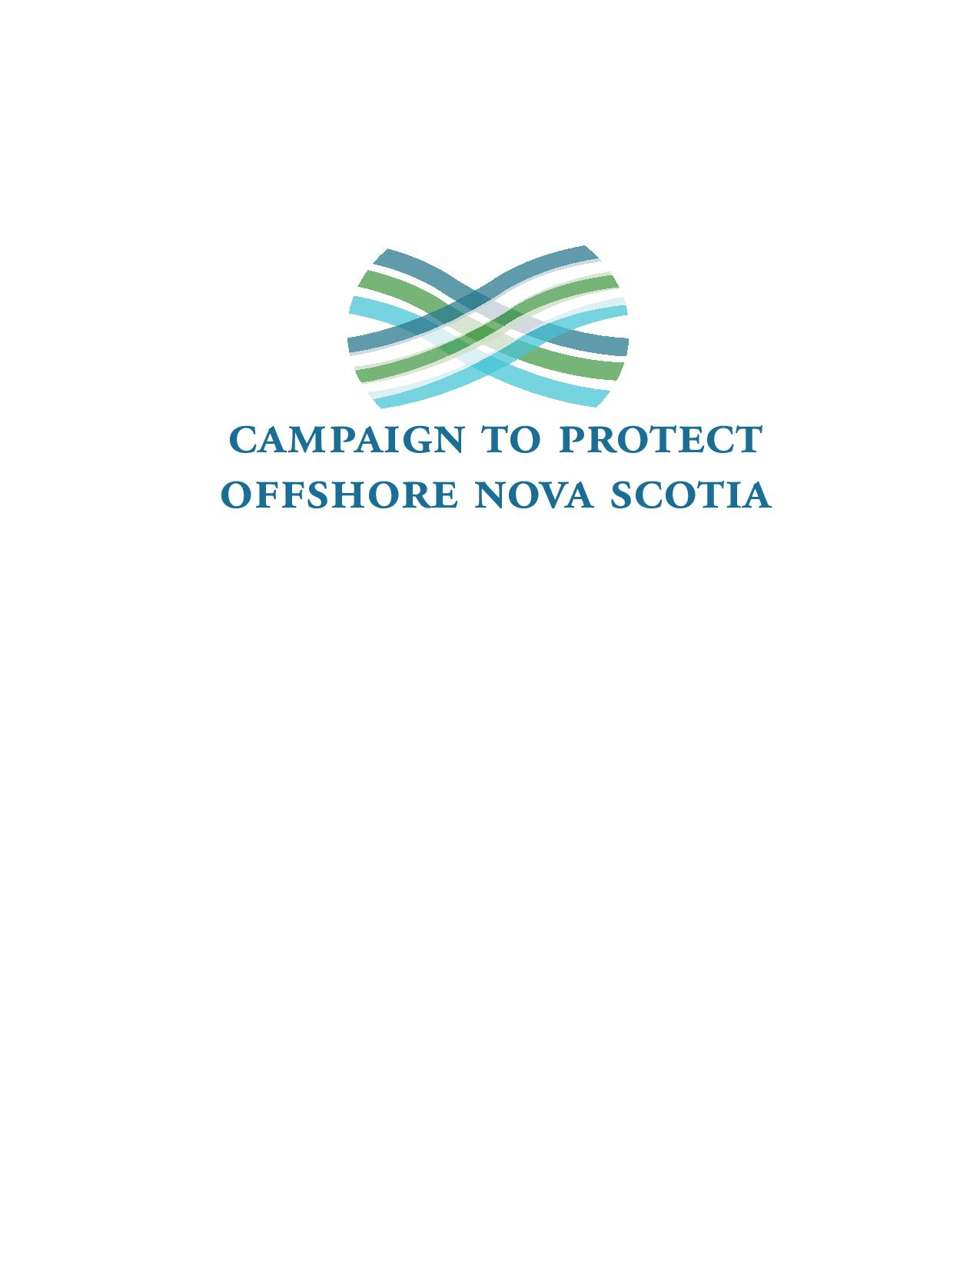

Comments on “The Scotia Basin Exploratory Drilling Project”

Draft Environmental Assessment Report
of the
Canadian Environmental Assessment Agency

December, 2017

Timing and Process

The most striking thing for residents of the South Shore of Nova Scotia, whose communities, livelihoods, economic base, and beloved living environments are most affected by decisions concerning development along the Scotian Shelf, is the lack of opportunity provided for informed participation in this EA.

To remember that BP’s Gulf Horizons disaster in 2010 affected a marine environment more than three times the area of Nova Scotia is to realize how critical are development decisions in the offshore to our communities, reliant for centuries on sustainable renewable marine resource industries.

Yet, public awareness of BP’s plans, and access to both the detail of those plans and expert advice on their efficacy, has been next to non-existent. For activity that has catastrophic potential (no matter how slim the likelihood in your estimation), this is not acceptable or just.
We commend your apparent effort to engage indigenous nations and communities in the EA process. The failure to make proportionate efforts to ensure the participation by the wider population along the South Shore is all the more remarkable. The fact that you can state, for example, on page 41 of your report, that “the Agency did not receive any comments from the public related specifically to fish and fish habitat”, speaks volumes about those left out of the process. The lack of public comment on this and a number of other areas of crucial import to the livelihoods of the people of the South Shore is less an indication of concurrence than it is of a failure to engage.
Only a public education effort that lays all relevant details on the table, along with well-advertised public hearings, could address this major drawback. Those hearings should take place in a number of affected communities, with independent publicly-funded, public interest cross-examination of industry representatives and government experts and allow for the calling of independent expert witnesses. Only such a process can yield conclusions and a decision that have legitimacy. Crucially, that process must acknowledge that rejection of the proposed development is an acceptable outcome.

Your EA claims to have “considered the views of the general public”. On what evidence is that claim based and how did those views affect your conclusions, specifically?

Risk Assessment vs. Acceptable Risk

As our Prime Minister argued on the 2015 campaign trail, “while governments grant permits for resource development, only communities can grant permission.”

Implicit in that statement is the understanding that risk assessment is not the same thing as determining “acceptable risk”. The latter can only be determined by those who bear the lion’s share of the risk – in the case of the BP proposal, that would be the communities dependent on the marine resources in the area in question.

Uttering reassurances like that on page iv of your report that “in the unlikely event of a spill, oil spill containment, recovery, and shoreline protection operations would be undertaken as quickly as possible,” amounts to a mockery of just and democratic process.

Only those who bear the risk can make such a determination. They have not yet been given that opportunity.

Lessons of the Gulf Horizons Disaster Ignored
The worst case scenario entertained in this EA is a blow-out whose “unmitigated release duration” lasts 30 days. It appears this number was drawn from a hat, with no reference to relevant experience.
It ignores the fact that the Gulf Horizons blow-out lasted almost three times that long, and in waters far shallower than those in the Scotian Basin. An earlier Nova Scotia blow-out, not all that far from BP’s proposed development (fortunately, at a gas exploratory well), lasted almost 8 months before it was capped successfully.

The proponent’s timelines and their dismissal of the likelihood of such a disaster lack an evidential basis.

Similarly, failing to require the presence of a capping stack within 24 hours, as is the requirement in Alaska, is inexcusable. Granting a period of 2 weeks or more before a capping stack is in place, trivializes the risk to the marine environment. Cost to the industry of such a requirement is tiny in the light of the risk and provides no excuse for the delay.
There is no basis for confidence in the statement on page 95 of the report that “in reality, oil spill response, containment and recovery or dispersion and shoreline protection operations would be undertaken to reduce adverse effects on marine and coastal resources.” Nor is there an evidential basis for the proponent’s claim “that the well could be capped and contained in 13 to 25 days, the upper limit allowing for weather-related or other delays.” (p95)
In the same vein, the proponent’s finding that oil from an unconstrained blow-out “would need to remain on the surface for one month or more (30 to 50 days) to reach shore from the spill site. “ is not reassuring when the actual life history of such blow-outs is taken into account.
As for spill response, the report relies on assurances from the proponent, the same company responsible for the Gulf Horizons disaster, that it has learned the lessons of that event and has put systems in place that will prevent a recurrence, or, in the unlikely event of an uncontrolled blow-out, ensure capture or disposal of the resultant spill. There being virtually no precedents for blow-outs at the depth of the drilling contemplated in the Scotian Basin, such assurances deserve to be treated with great scepticism, if not dismissed outright.
The response strategies outlined by the proponent, from containment and use of booms (in the stormy North Atlantic, no less!), to dispersant use on the surface and in the water column, have all been found inadequate to the task by researchers examining the Gulf Horizons experience. In fact, many have concluded, where response strategies were not simply ineffective, they actually inflicted greater damage on marine life than had the spill been left to natural processes to deal with.
After all the evidence to the contrary, it strains credulity to read the proponent’s assertion, then, that “in an actual incident, emergency response measures would likely limit the magnitude and duration of the spill thereby reducing the size of the area affected and the potential environmental effects……. effects of a blowout on fish and fish habitat would not likely be significant.” (p103) We should likewise treat the proponent’s assurances regarding effects of a blow-out on marine mammals, birds and endangered species with a grain of salt.
The proponent admits that the effects of a uncontrolled spill could reach the fishing grounds on the Emerald Bank in as little as 6 days and Georges Bank in as little as 20 days, both frightening possibilities. Once again, the suggestion that mitigation measures might prevent this is without evidential foundation. The catastrophic consequences of such an event are barely recognized.
The EA refers frequently to the CNSOPB’s competence in ensuring risk management by the proponent and mitigation of spill consequences. A typical reference is the following; “The spill response plan would be required to meet the CNSOPB’s regulatory standards and be appropriate for the scenarios that could occur. “ (p122) Such confidence is unwarranted, given the Board’s make-up and pro-industry bias, and its consequent tendency to downplay risk to traditional industries. The decisions of the CNSOPB lack legitimacy and will not engender public trust until the Board is reformed to address its unrepresentative membership and other issues in its practices.
In this respect, it is important to note that the federal Departments of Fisheries and Environment, who are responsible for the environmental protection of our oceans should desist from handing over their clear responsibilities to protect the environment to unelected, unrepresentative, oil industry-oriented, cheerleaders for oil resource development. Recent indications that the federal government is intent on reaffirming its predecessor’s plan to transfer responsibility for environmental impact assessment to the offshore boards are deeply disturbing and a clear backward step for environmental protection in the offshore.
The truth is that there is no effective, historically proven, response to an oil blow-out in waters as deep as the proposed BP project. To pretend otherwise is to ignore the evidence and to mislead the public. Once more, the results of research on the response to the BP Gulf Horizons blow-out confirm this conclusion.

In the case of the Gulf Horizons disaster, US analysts conclude less than 10 per cent of the oil was ever recovered, while industry attempts to disperse and degrade it at sea were at best a failure, and at worst, inflicted additional harm on marine species throughout the water column. The impact on the Gulf Coast industries of fishing and tourism has been estimated at well over $25 billion and continues to makes itself felt today, almost 8 years after the fact.

There appears to be no recognition of that record in your EA. It should be front and centre.

How Does this Development Fit with Canada’s Paris Commitments?

Plans like those of BP do not happen in a vacuum of energy policy. Nor should they be assessed as if they did.

We already know that if we are to meet our climate change commitments a high percentage of Canada’s already proven oil reserves will have to remain in the ground. It is interesting to note, in this regard, the recent decision of the World Bank to deny investment funds to countries for oil and gas exploration for exactly this reason. Should Canada live by a different standard? How does proving up additional high cost oil reserves fit with meeting our Paris targets to reduce carbon emissions?

How does that influence your assessment of the acceptability of the risks to our sustainable renewable marine resources inherent in the BP plan?

It would be one thing if the country needed the oil BP seeks in our offshore. A case for taking the risk might be plausibly tendered in that case. It is a very different thing when the oil is not needed, and when the investment might incur a far better return were it made in conservation or in renewable energy sources.

It might be argued that any oil discovered in Nova Scotia’s offshore would be destined not for domestic consumption, but for offshore markets, as if that might absolve Canada of responsibility for its climate change impact when the energy is consumed abroad. While this might fit a strictly legal interpretation of the Paris Accords, we reject that abdication of responsibility as contrary to their spirit and intent and unworthy of our country.

Conclusion

This is necessarily a cursory response to your call for public comment. However, it should be clear that we think your positive conclusions regarding the proposed BP exploratory drilling program are not warranted on the basis of the evidence the proponent and you provide, while they are often contradicted by the evidence you appear to ignore.

The lack of serious informed public participation in support of your conclusions is also salutary and delegitimizes your results.

In conclusion, we do not believe the BP plan is justified at this time. Further informed public study is certainly warranted before it receives approval from the CEAA, let alone the Canada/Nova Scotia Offshore Petroleum Board, whose make-up and processes also lack democratic legitimacy.

In our opinion there should be a moratorium on further exploration for non-renewable energy resources in our offshore until such time as the decision-making process can reasonably be deemed democratic.

CPONS, Lunenburg, December, 2017

